

Ajeevika SHG Enterprise App User Manual

|  |
| --- |
|  |
|  |
| SHG Enterprise App User Manual  By Kamtech Associates |

Contents

1.0. General Information 3

1.1. Application Overview 4

1.2. Hardware and Software Requirements 4

1.3. Purpose of the document 4

1.4. Disclaimer 4

1.5. Downloading Application (for demonstration purpose) 5

1.6. Opening Application 5

2.0. User, Accounts & Profile 6

2.1. Sign Up 6

2.2. Login & Logout 7

2.3. Forget Password 8

2.4. Profile 9

2.5. Overview of Home Page 10

3.0. Product Management 11

3.1. Product Listing 11

3.2. Product Editing 14

4.0. Order Management 15

4.1. Interests from Buyers 15

4.2. Accepting Orders 16

5.0. SHG Enterprise 18

6.0. CLF 18

7.0. Other Features 18

7.1. Change Language 18

7.2. Grievances 19

# General Information

|  |
| --- |
| Application Overview “Ajeevika Seller” is a is a web platform and android mobile app for the Sellers (SHG Enterprise, CLF, Saras Center and Growth Center) enabling them to upload and sell products to buyers. Hardware and Software Requirements  * Requires a smart phone with Android operating system (OS) minimum Android version should be 5.0 and above. * To download and use the functionalities of Ajeevika mobile app, you require an Internet connection in your mobile. * An active email account.  Purpose of the document This document is aimed at serving as a guide for Sellers on the use of the Ajeevika Mobile App. The document can also help the district admins and government officials in understanding of the buyer application. User Access Levels There are four types of roles in Ajeevika Seller Application namely SHG Enterprise, CLF, Saras Center and Growth Center   1. CLF, Saras Center and Growth Center: These user groups act as middlemen on the platform, they can buy the produce from SHG Individuals and then upload and sell their products on the platform to buyers. 2. SHG Enterprise: This user group can directly upload their products on the platform for sale to buyers. They don’t have a provision to buy from SHG individuals.  Disclaimer The mobile app is android based and can only be installed on android devices.  This document is prepared as an artifact to facilitate training on the digital product  developed under "Technical support for the upgradation, enhancement of Uttarakhand Ajeevika and creation of Marketplace module".  Best effort has been put to ensure that the content of this document is in sync with  the actual product, however, since software products can undergo multiple  changes, hence it is not guaranteed that this document aligns with the latest product  version.  The creator or owner of this document does not accept any liability of any untoward repercussions arising out of the product usage or information mentioned in this document. All the rights of this document lie with the owner of the above-  mentioned digital product. |

Getting Started

## Downloading Application (for demonstration purpose)

Ajeevika application can be downloaded via Google Play Store. To download the application follow the following steps:

Step 1: Open Play Store application on your mobile by clicking on the Play Store icon as shown in the image below.

Step 2: Click on the Google Play text at the top and enter the text "Ajeevika" in the search bar. Click on the Ajeevika application icon from the search result.

Step 3: Click on the "INSTALL" button to install the application.

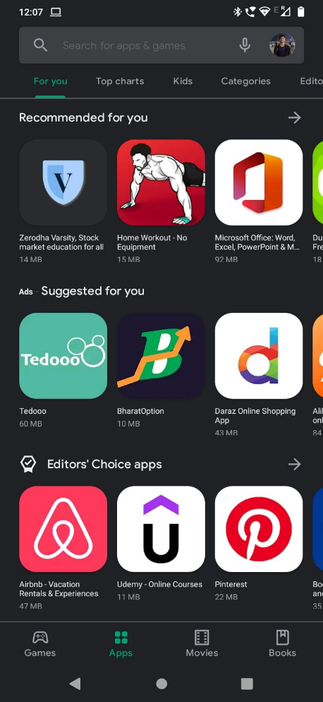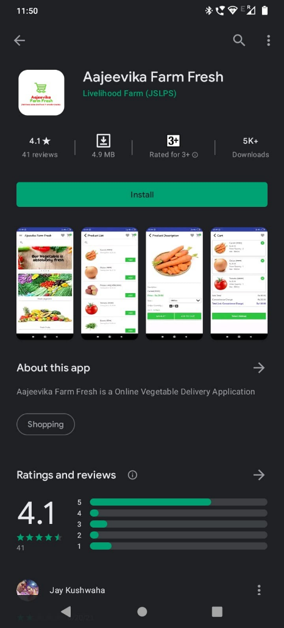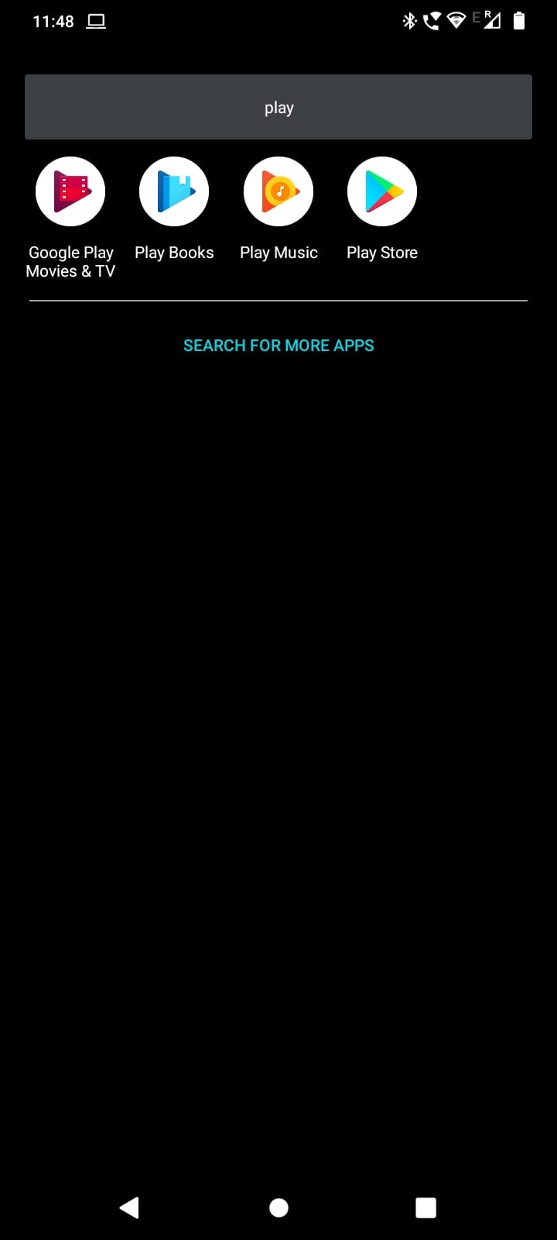

## Opening Application

Step 1: To find the application open your app drawer in android phone, and search “Ajeevika Seller”

Step 2: Click on “Ajeevika Seller” icon in the app drawer.

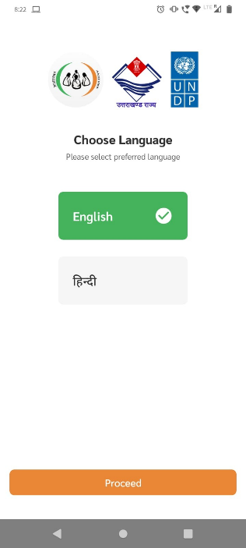Step 3: Choose the language of your choice.

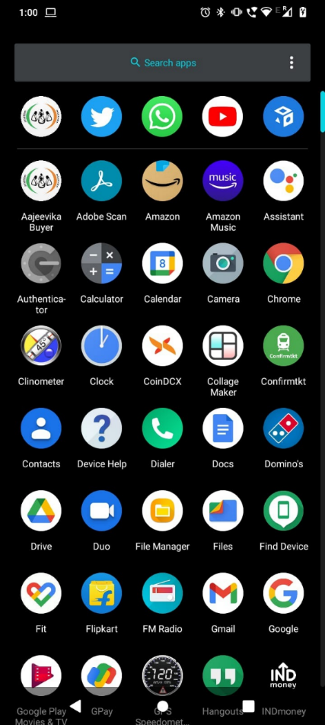

# User, Accounts & Profile

## Sign Up

When you open the application for the first time you will be greeted with the page shown below, To access the application you will need an account. To open the account follow the steps below:

Step 1: Click on “Click to Register” text on the bottom of the page.

Step 2: Here the first option (Sign-up As*) is to select the type of account you want to create

1. CLF
2. SHG Enterprise
3. Saras Centre
4. Growth Centre

Step 3: Fill in the required details viz a viz your Organisation name, member Name, designation email ID, phone no., password (should be min of 8 characters).

Step 4: After filling all the details click on Check box for T&C & Privacy Policy and click on SignUp button.

Step 5: Enter OTP, received on your registered Phone No. and click on Verify button.

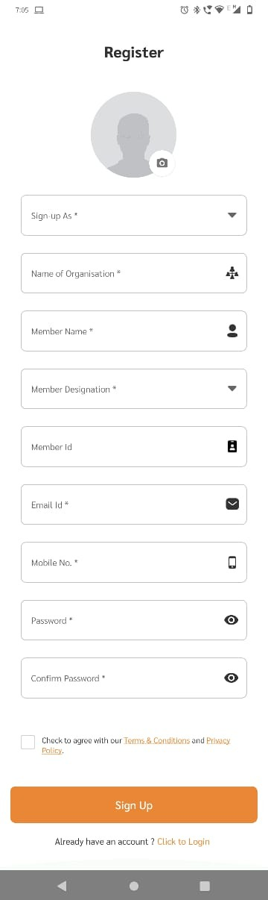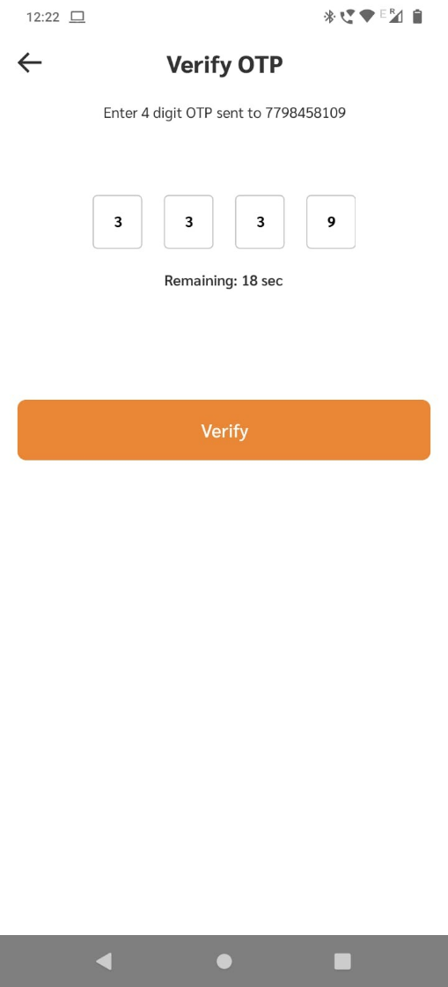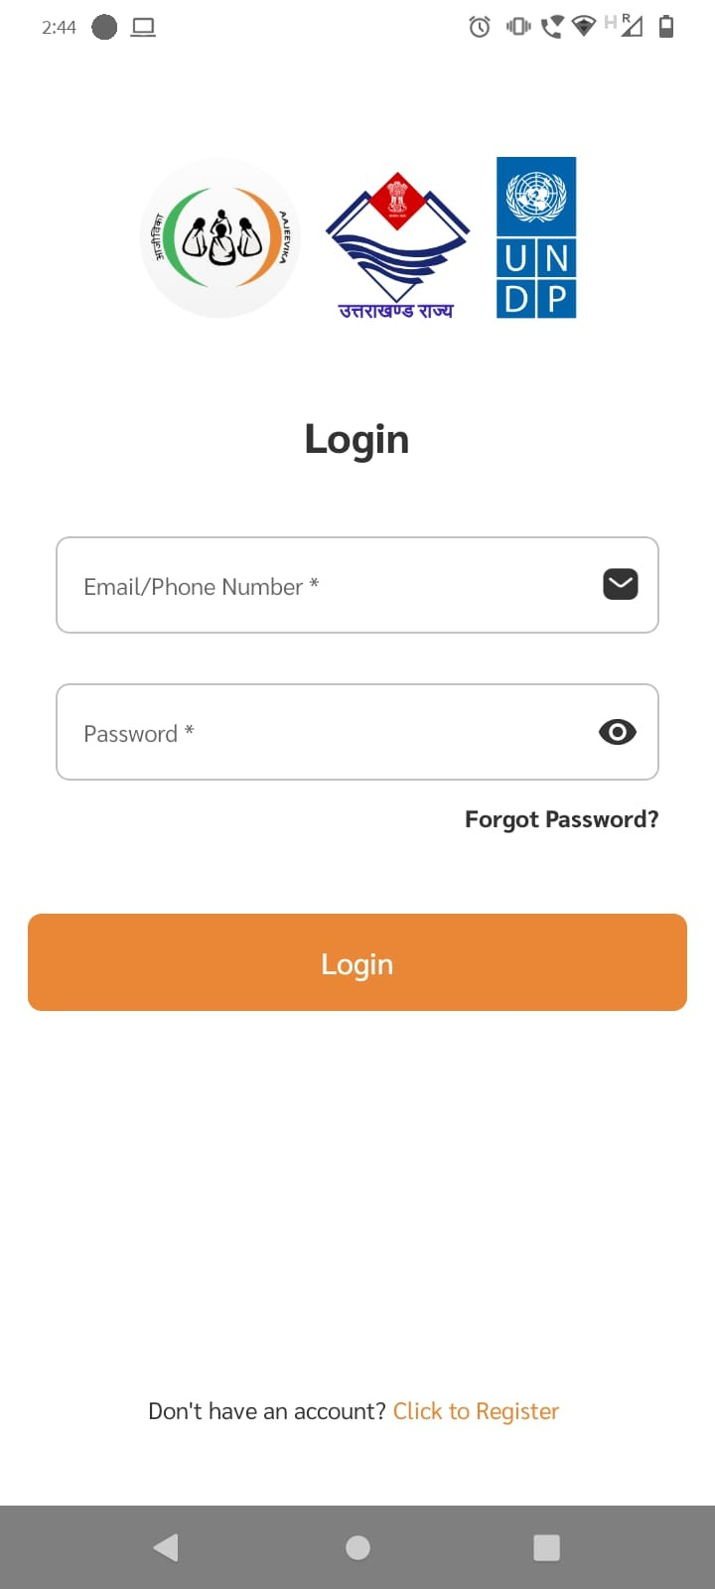

## Login & Logout

Once you create account you will be directly redirect into Home Page (which we will discuss below), but if you need to login/logout again follow the following steps:

Step 1: Open the application and enter your login credentials i.e email Id & password and click on Login button. You are successfully logged in.

Step 2: To logout click on menu button shown below, a side pane will pop up.

Step 3: Click on Logout button from the side pane.

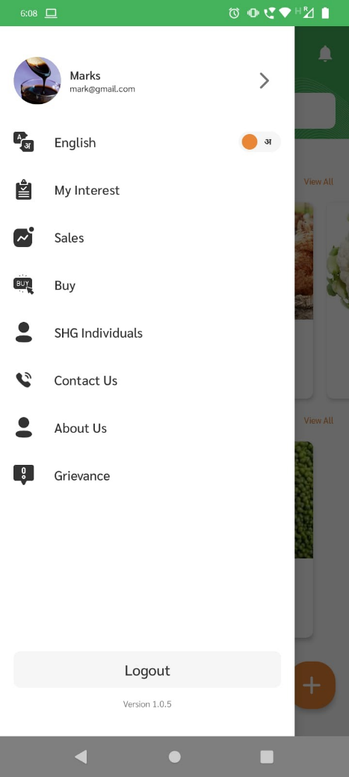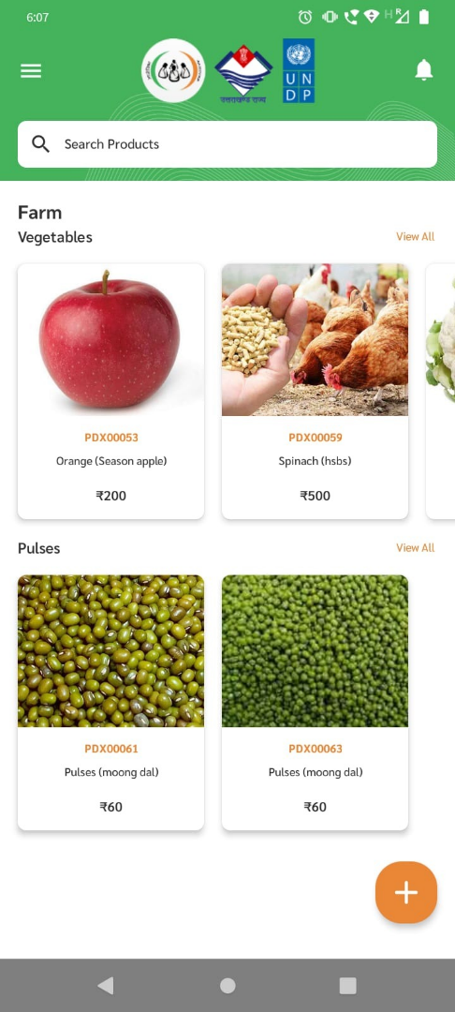

## Forget Password

If you forget your password, then don’t worry follow the following steps to change your password.

Step 1: Click on “forget password?” text shown below.

Step 2: Enter your registered mobile no. and click on Verify button

Step 3: Enter OTP received on your mobile no.

Step 4: Create new password and confirm your password and click on Save button.

Now you have successfully reset your password.

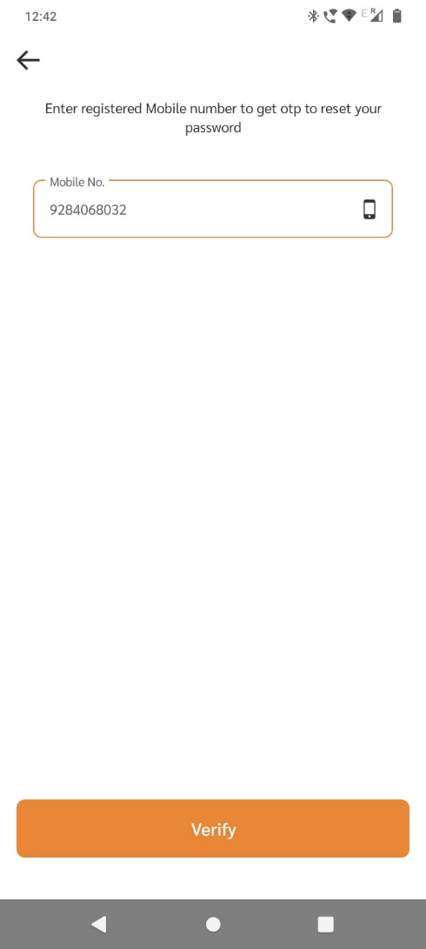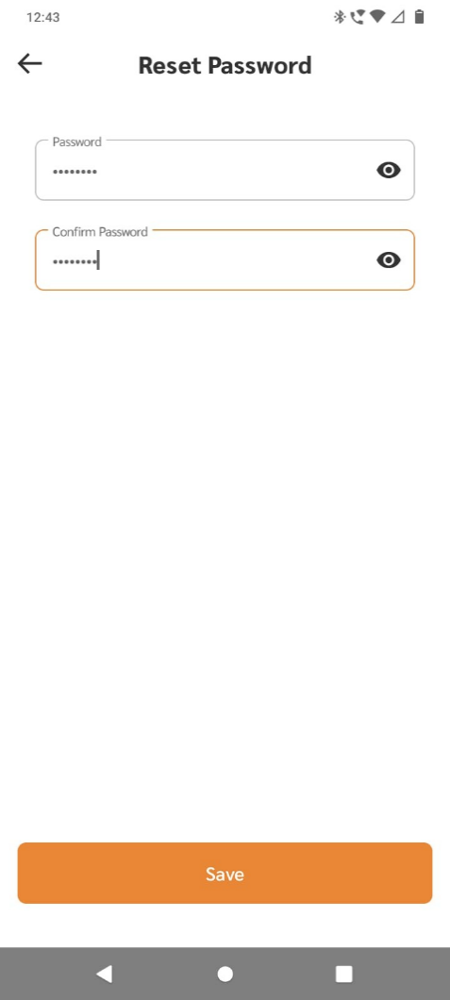

## Profile

The profile section will allow you to update user information.

Step 1: To go to profile page click on menu button and in the side-pane click on “My Profile” button.

Step 2: To update/change user information click on “Edit” button on top right corner.

Step 3: In Edit Profile, you can change your information i.e Organisation name, member name, designation, email Id, mobile No., address etc.

Step 4: After making necessary changes click on “Save Changes” button.

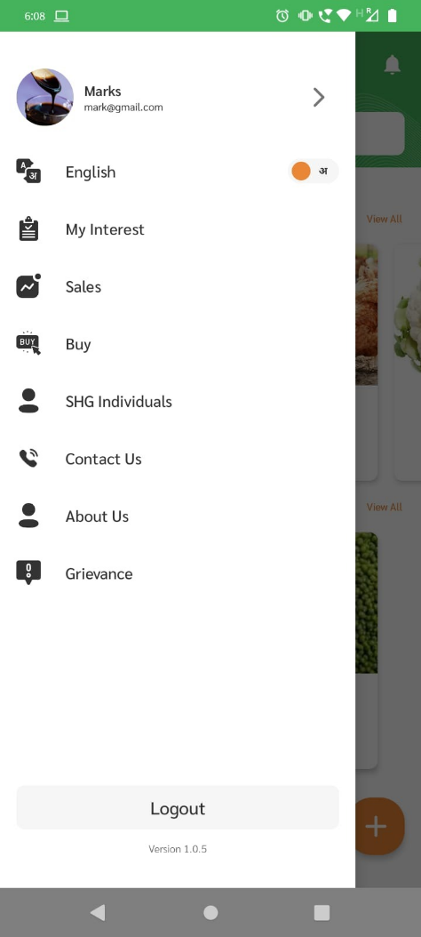

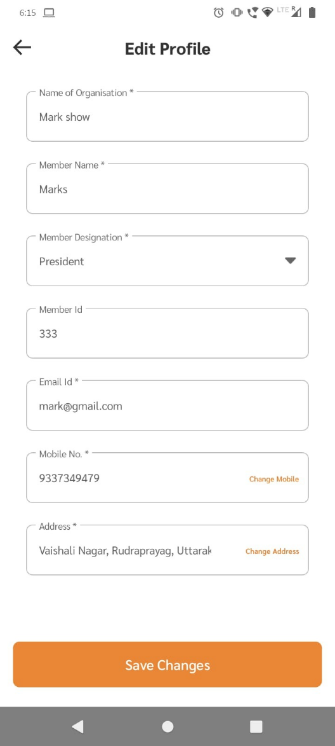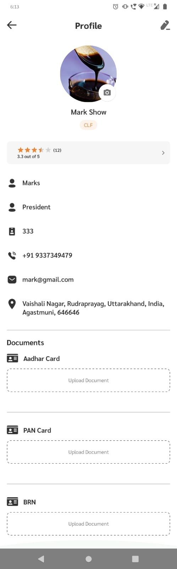

## Overview of Home Page

When you open the application, you will be greeted with this home page with lots of different buttons and features, all of them is explained below.

Menu Button

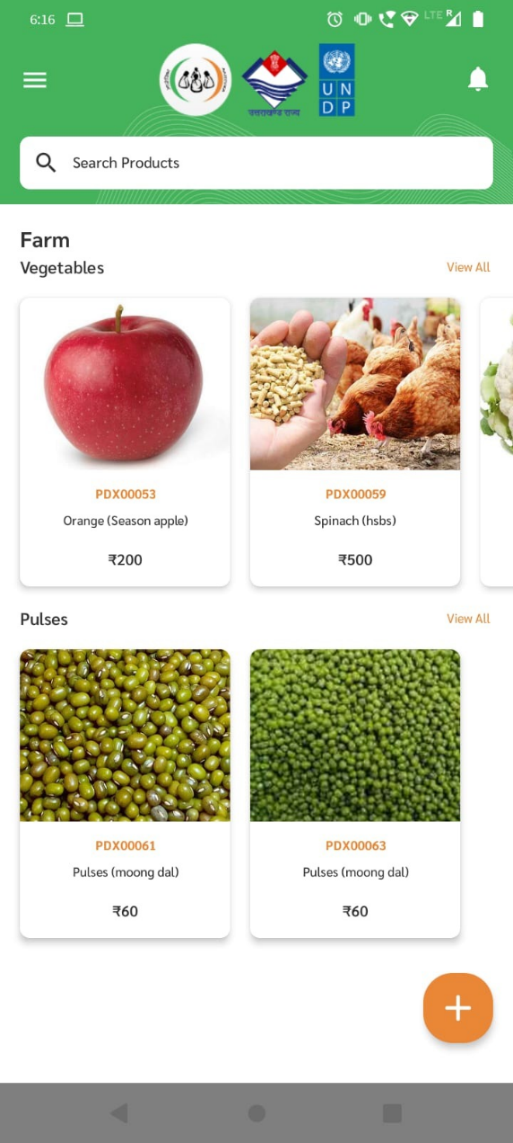

View All button to show all products under similar category

Your Products

Add new product button

Products organised in groups

Notification Button

# Product Management

## Product Listing

To list any product on the platform seller needs to follow the steps below:

Step 1: Click on the plus button on bottom right corner, yow will be taken into “Product Add” page.

Step 2: Select product category from the dropdown options.

Step 3: Now select the sub-category for from the dropdown list for the given category.

(Every given category have their own respective sub-category, Product type & Product name)

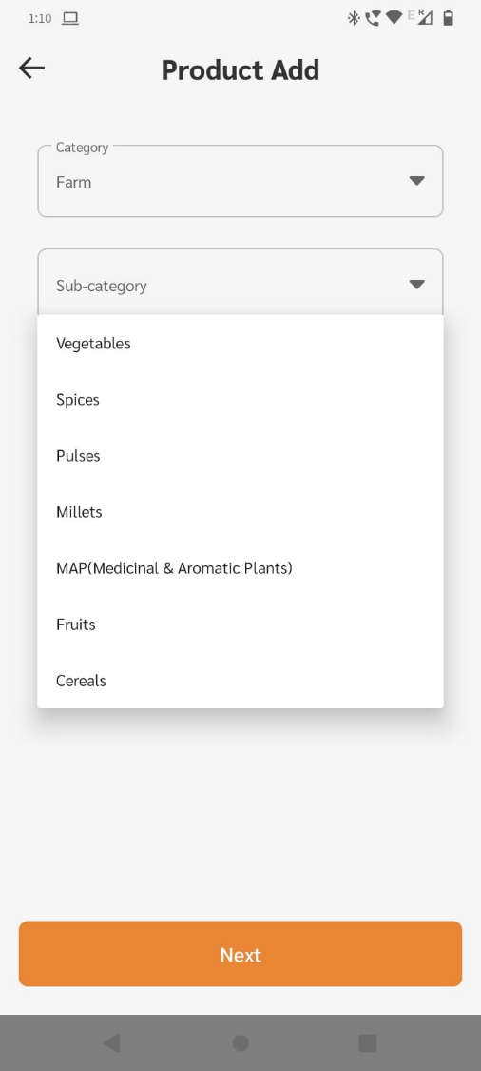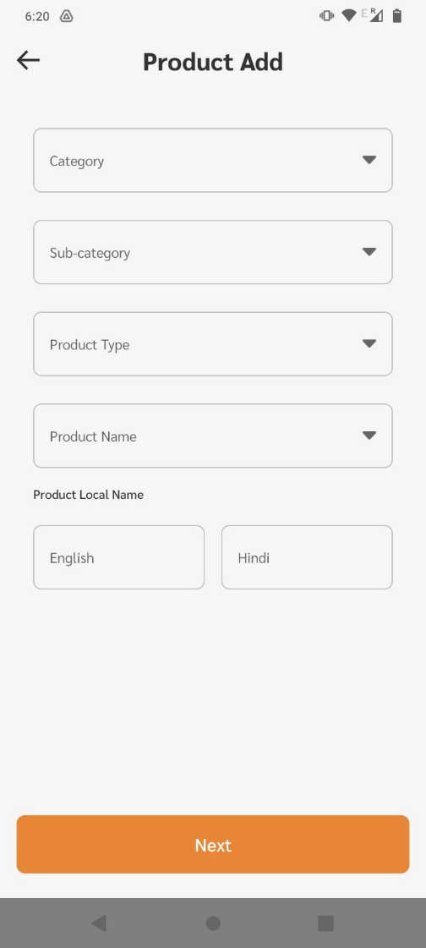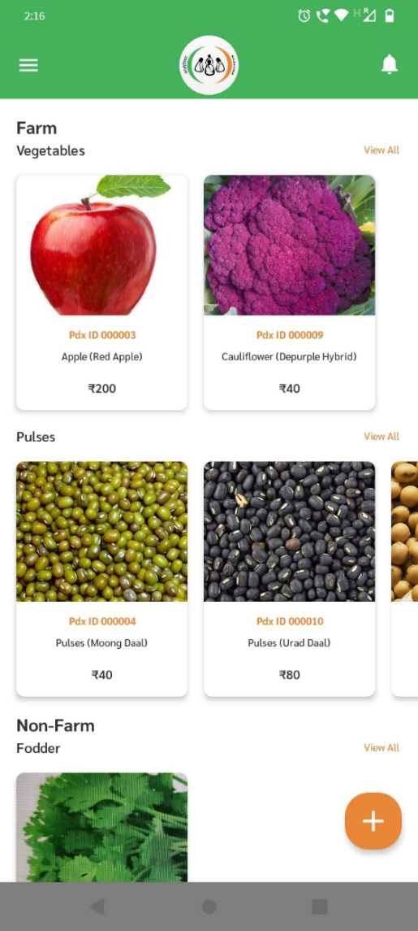

Step 4: Now select the Product Name from given dropdown option from a pre existing product template.

Step 5: After selecting product name, select product type i.e organic or Non-organic .

Step 6: Now write the name of product in English as well as in Hindi.

Step 7: After filling all information on this page click “Next” button.

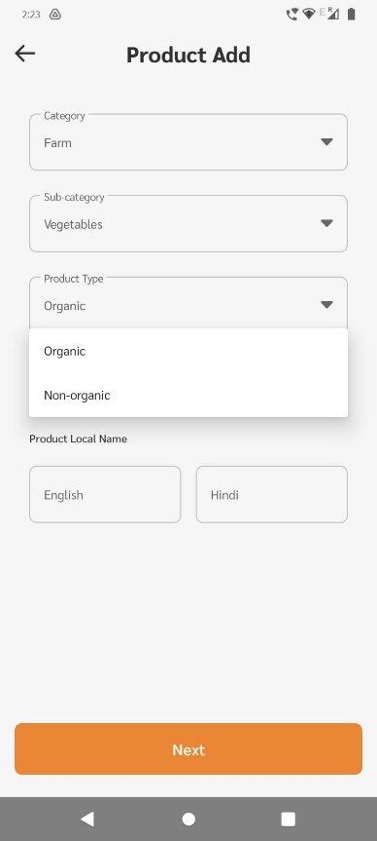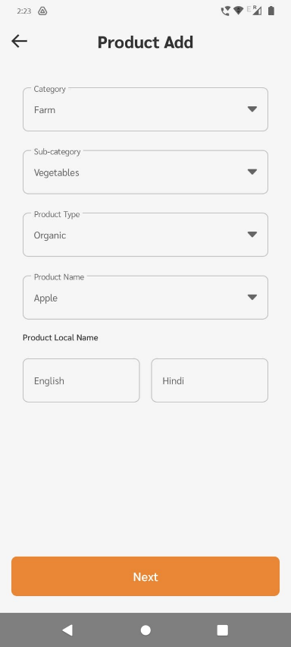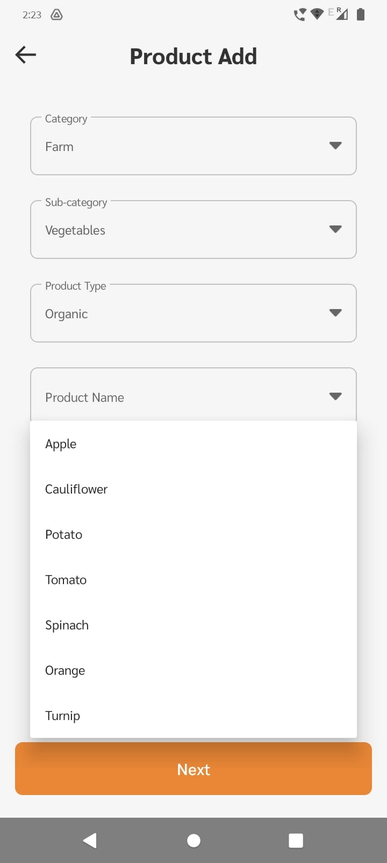

Step 8: On the Next page input product availability, unit price and unit of quantity shown below (KG, Liter, Meter etc.), and add actual product image (min 1) & click on “Next”.

Step 9: Now Add product images, seller should upload minimum 1 image and maximum of 5.

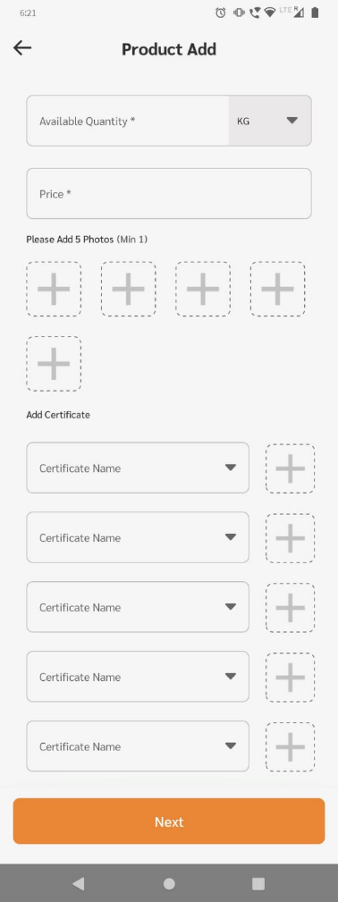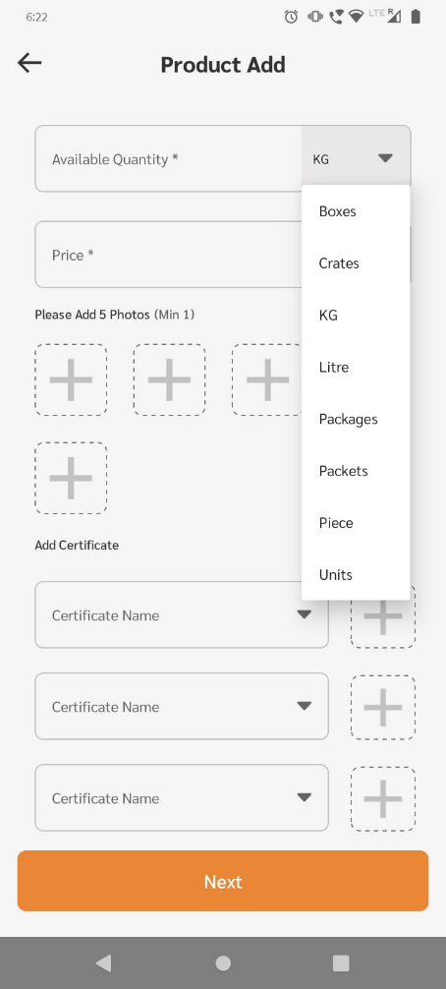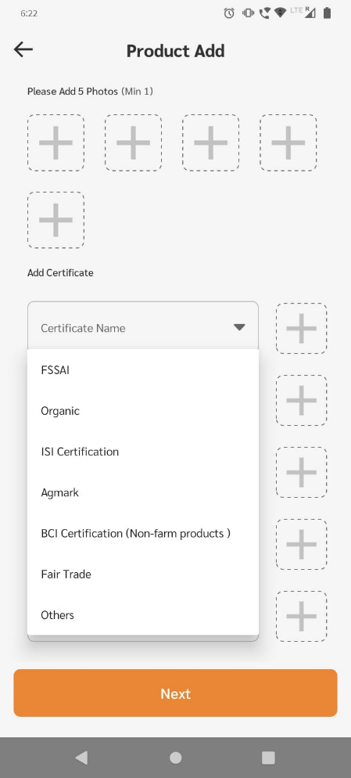

Step 10: Now sellers can add by selecting certificate from dropdown list and clicking on + button next to it to upload certificate.

Step 11: After adding certificates click on “Next” button on the bottom of the page

Step 12: On this page there will a default product description from product template, you can edit the default description by clicking edit option on top right corner, and click “Add” button to add product.

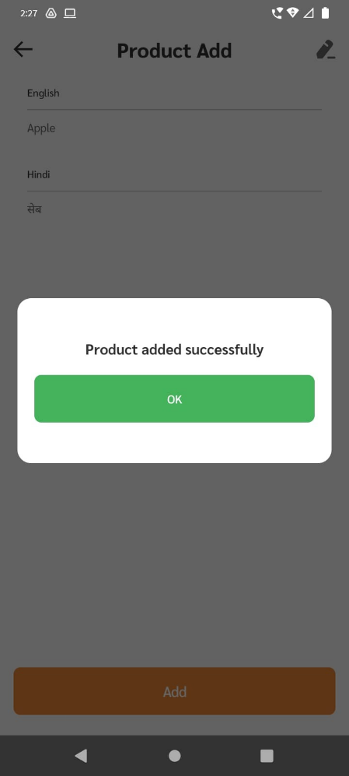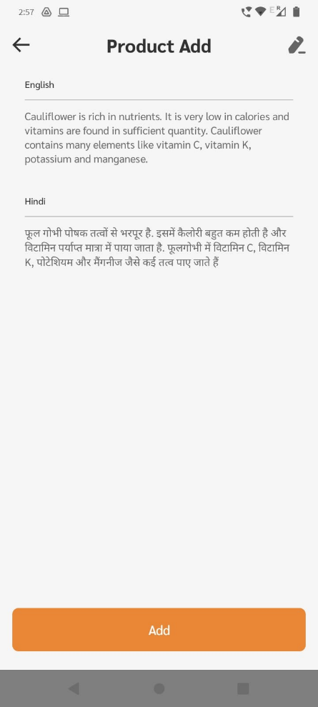

## Product Editing

To change any information of already listed product(s) follow the steps below:

Step 1: On the home page click on any product you want to edit.

Step 2: Click on “Edit” button shown below.

Step 3: Follow the same steps from section 4.1 Product Listing to make changes into product.

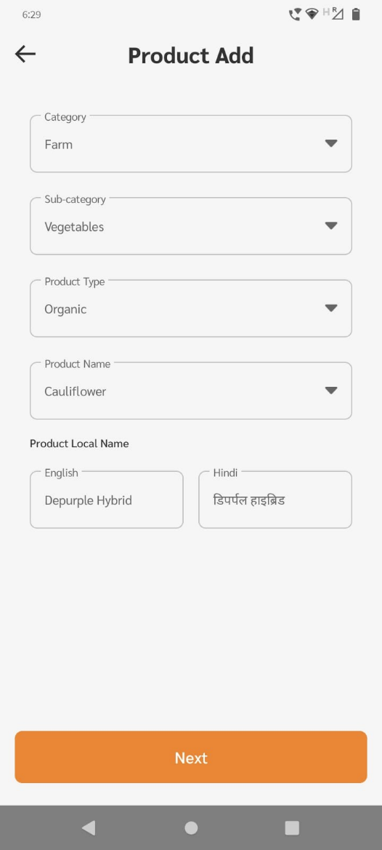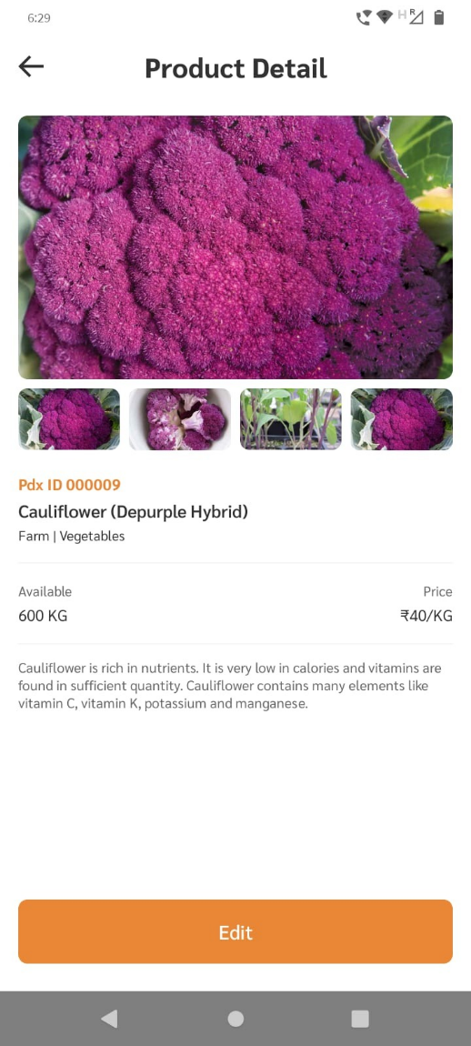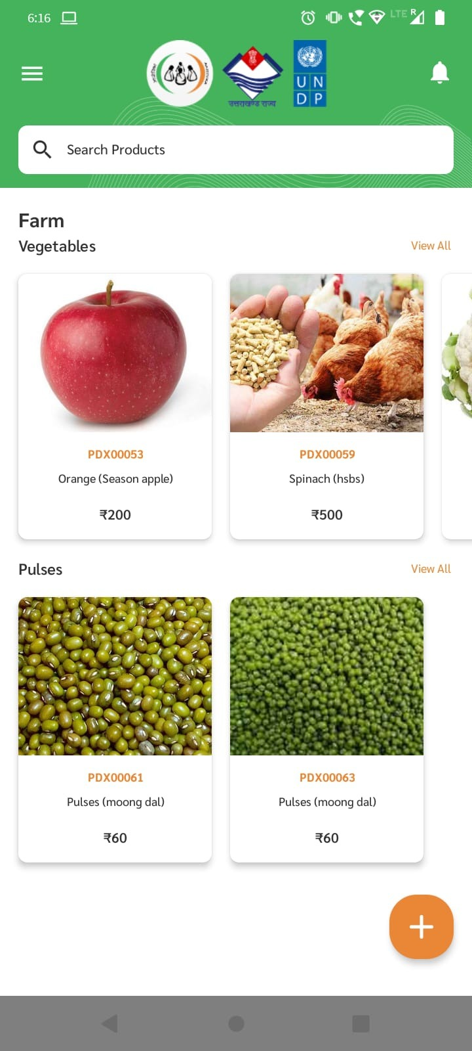

# Order Management

## Interests from Buyers

Interest from buyers for your product will be shown under “My Interest” page. To view the interests, follow the steps given below:

Step 1: Click on the menu button on top left corner in the home page, a side pane will open.

Step 2: From the side pane click on “My Interest” button.

Step 3: Here you will find list of all customers who have shown who have expressed interest in your product.

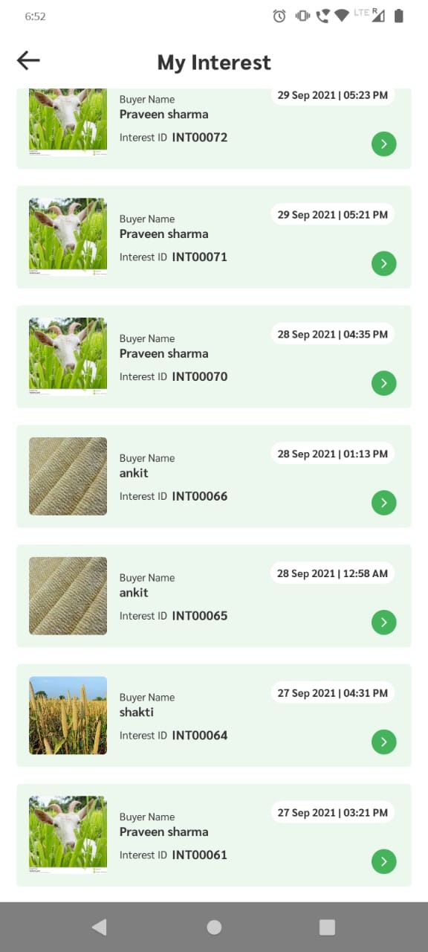 Step 4: To view the details click on the box.

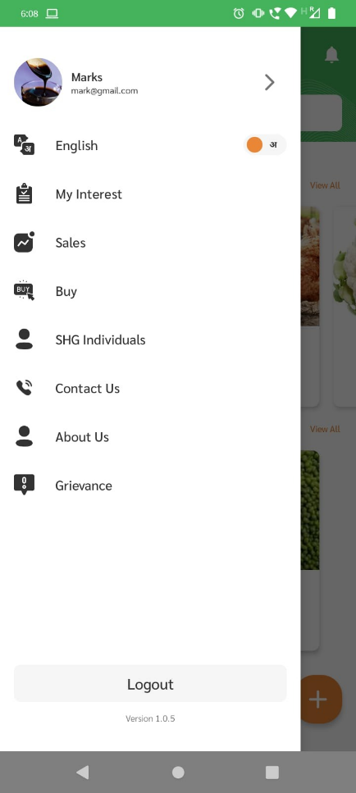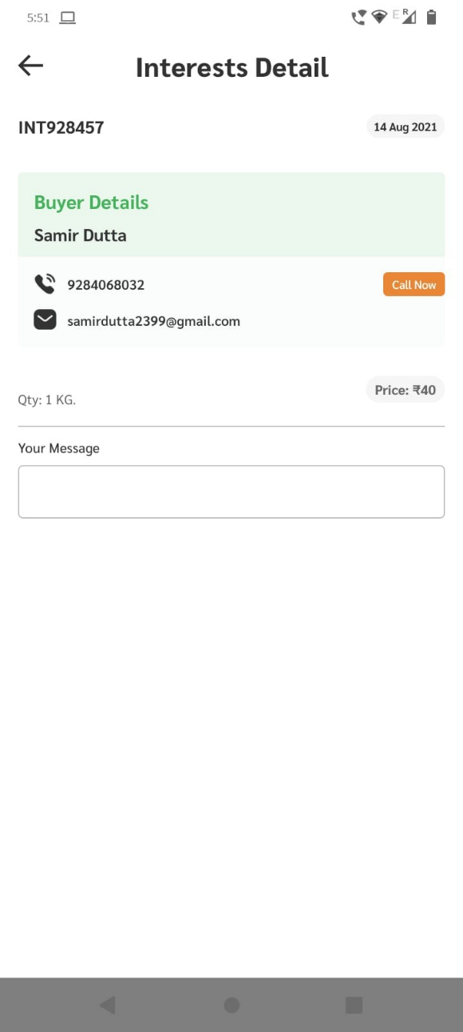

Message from buyer

Order Details

Buyer’s contact details

Buyer’s Name

Order No.

Date of Contact

## Accepting Orders

To confirm the orders from buyer’s interests follow the steps below:

Step 1: Click on the menu button on top left corner in the home page, a side pane will open.

Step 2: From the side pane click on “Sales” button

Step 3: To accept a new order click on” Add New Sale” button.

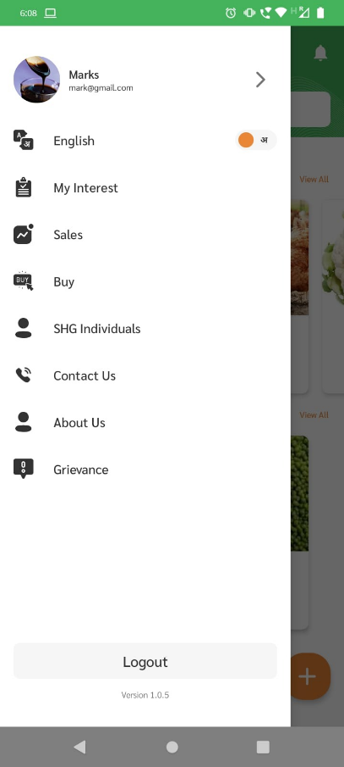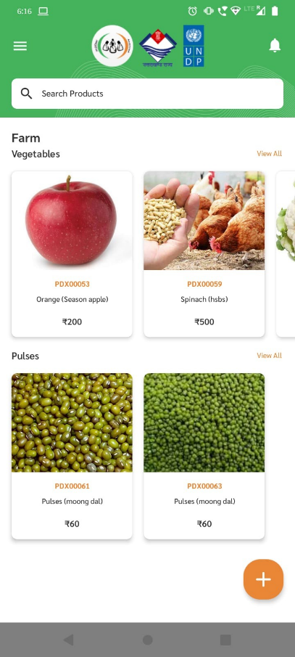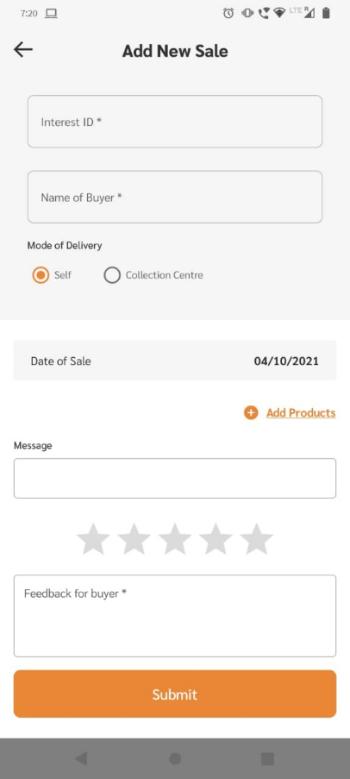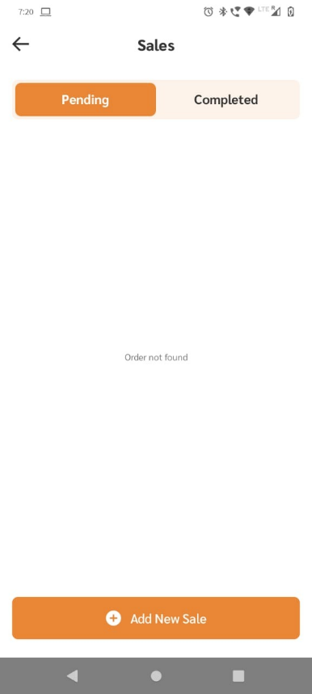

Step 4: Click on “Interest ID” box, existing list of interests from my interest page will appear, click on interest you want to fulfill, the order details will automatically be filled based on interest from buyer.

Step 5: Here seller has option to change/edit order details if he/she does not have the required product quantity or type, by clicking delete icon and then by clicking “+ Add products” option shown below.

Step 6: Seller also have option to add a message to buyer and also to rate the order out of 5 stars.

Step 7: Mode of Delivery, seller has option to place order under 2 modes of delivery depending on order by order basis or upon customer preference.

1. Self
2. Collection Centre

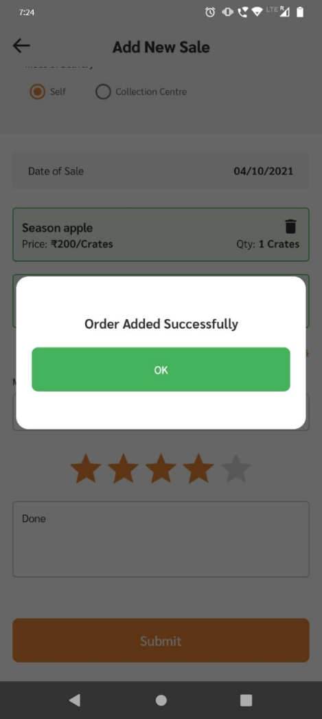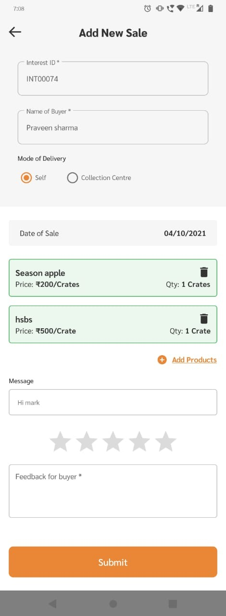

Step 8: After completing every step mentioned above click on “Submit Button”

Congratulations! Your Order has been confirmed, Your respective customer will be notified.

# CLF

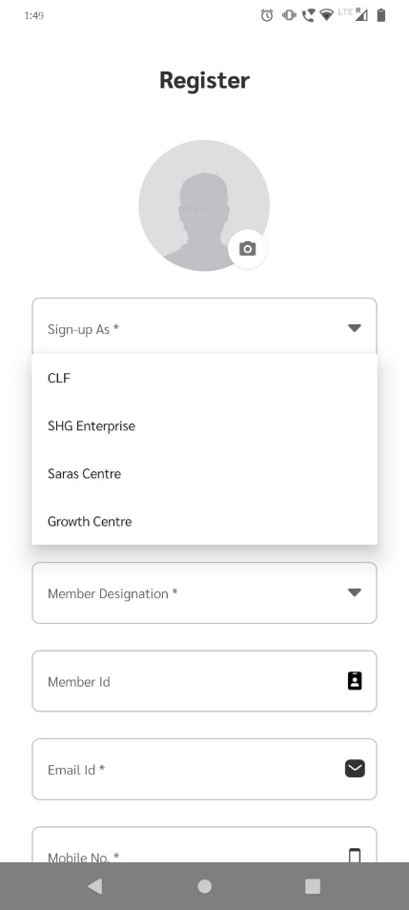Unlike SHG Enterprise, CLF will have access to two additional modules namely “Buy” Module & SHG Individual module.

## Buy Module

To access Buy Manager click on “Buy” button under menu shown above.

In “Buy Manager” you will have list of all the sales made and an option to leave a written feedback to buyer as well as a star rating.

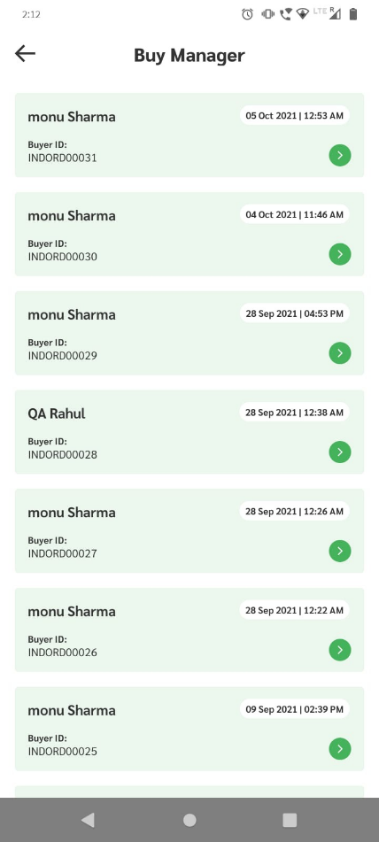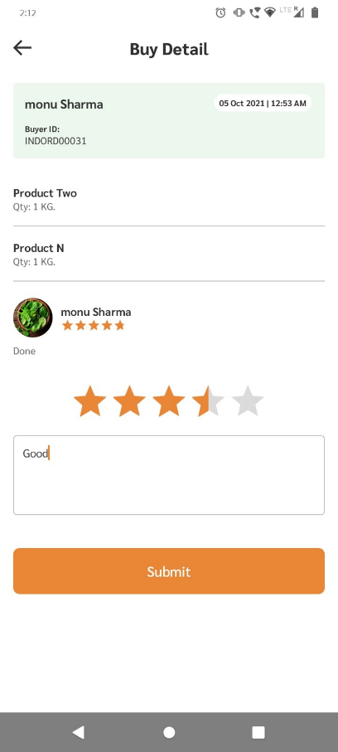

## SHG Individuals

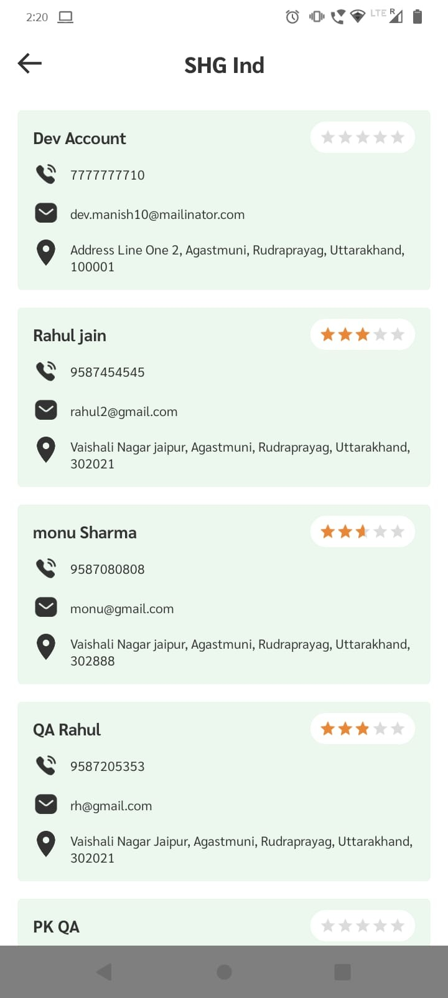

# SHG Enterprise

When you sign-up as SHG Enterprise (while setting up the account), you will not have access to “Buy” Module and “SHG Individuals” Module.

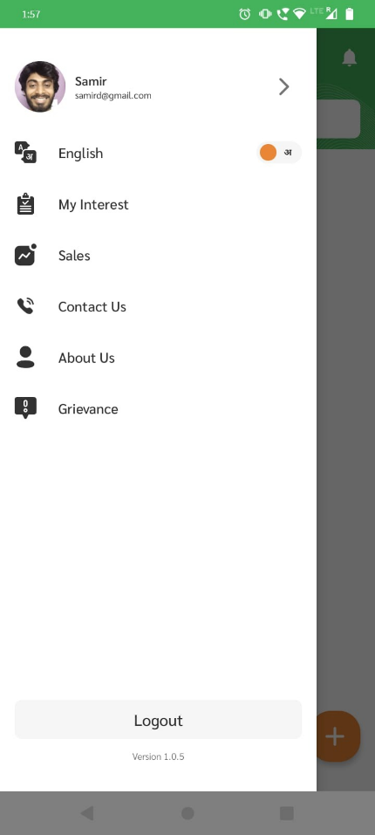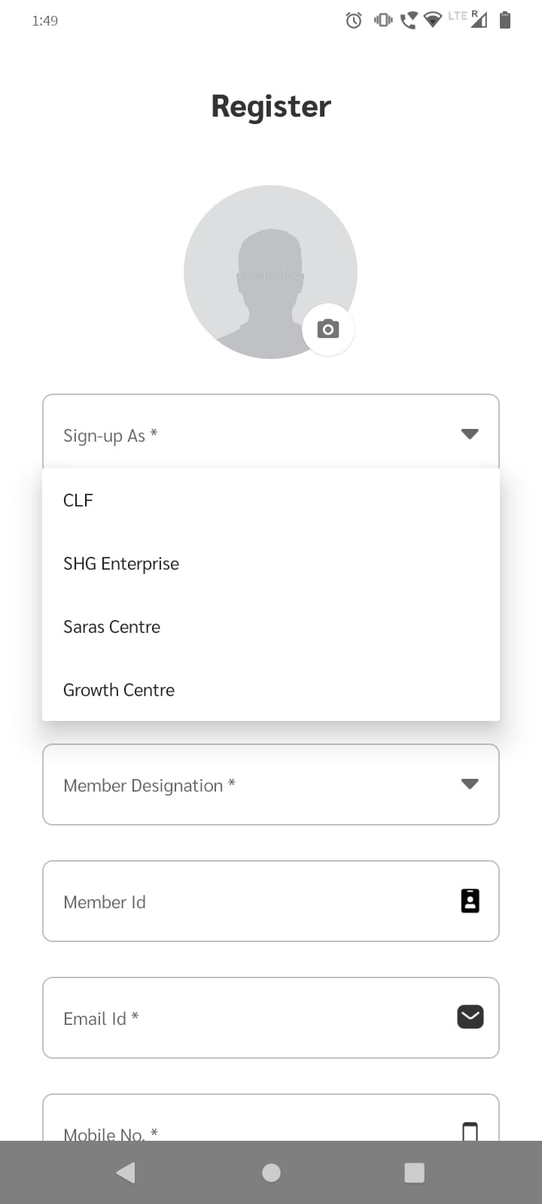

# Other Features

## Change Language

To change language follow the steps below:

Step 1: Click on menu button on homepage

Step 2: From side-pane click language toggle button.

Now the language of the entire app will change.

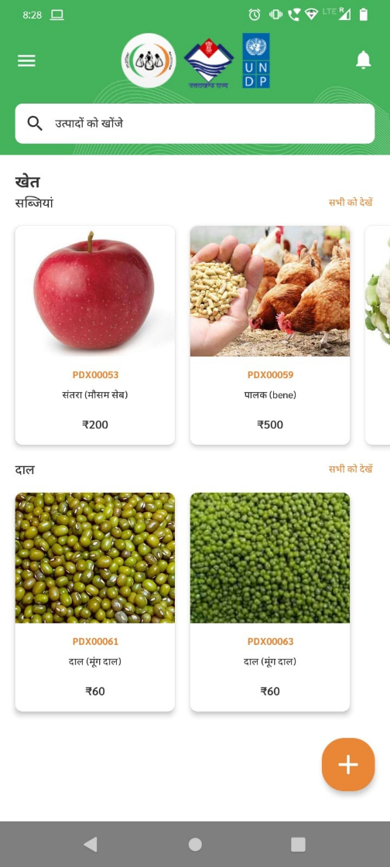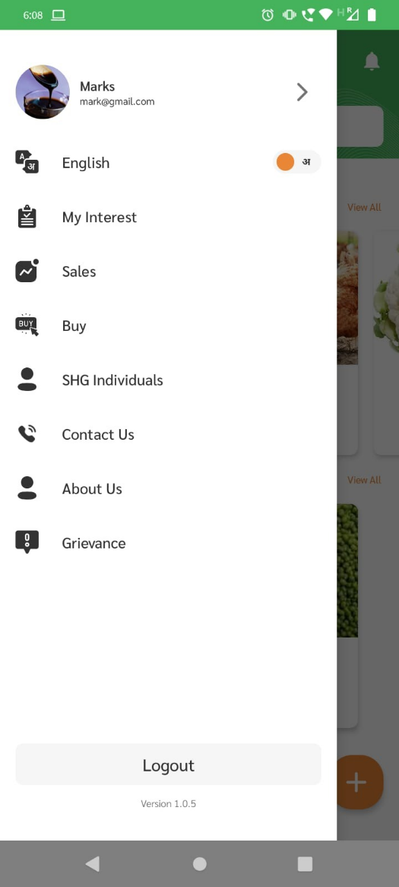

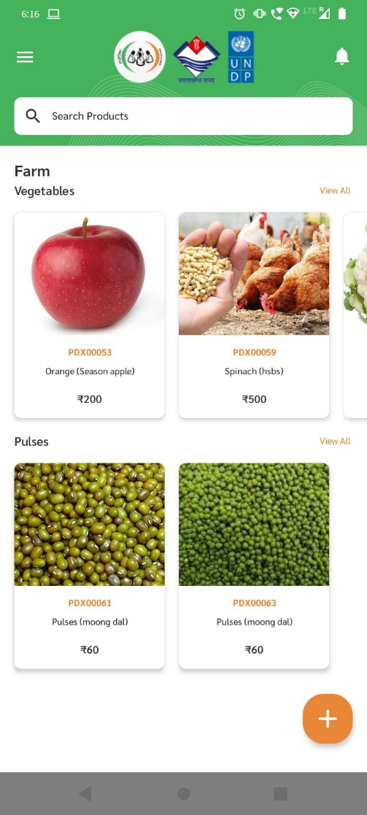

## Grievances

In order to raise an issue users can built in grievances section in the app, In order to access grievances follow the steps below:

Step 1: Go to side pane and click on “Grievances”

Step 2: Click on “Raise Ticket” at the bottom.

Step 3: Select your issue from dropdown, and explain in the text field below

Step 4: Click on “Submit”

